Cheese
Cheese, milk fermented food made from the pressed curds of milk, firm and elastic or soft and semi liquid in texture. Cheese can be classified into different categories based on their moisture, the way the milk is processed, and the types of microorganisms used for the ripening process. In the processing of cheese, the amount of curd used for each block of cheese to be made differs considerably. Harder cheeses have much larger blocks as compared to soft cheeses. This may be due to the ease of handling after ripening.
Cheeses are packaged in different forms to meet the consumption patterns by consumers and to some extent the way the cheese is ripened and for marketing purposes. The various packaging materials are selected to protect the cheeses in a sanitary condition, extend the shelf life, and delay the deterioration of the final products. Table 10 lists some of the requirements of cheese packaging materials
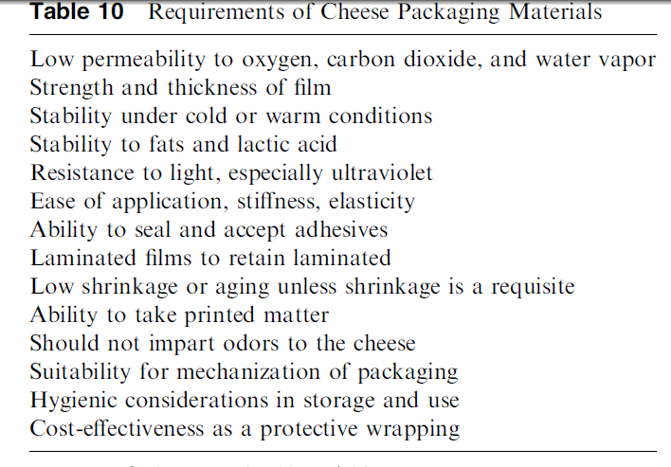
All the cheeses produced have to be coagulated from acceptable milk to form the curd followed by removal of the whey. Most of the cheeses are made from standardized and pasteurized milk. Nonpasteurized milk is also used in some exceptional cases provided that the raw materials don’t carry pathogens. The majority of cheeses are made from cow’s milk.
Milks from other animals are also used for specialty products. The coagulation process is conducted through the addition of the coagulant (rennin or chymosin) and incubation of appropriate lactic acid bacteria in milk to produce enough acid and appropriate pH for curdling of the milk. After the casein is recovered, it is salted and subject to fermentation with or without inoculation with other microorganisms to produce the desirable characteristics of the various cheeses.
Due the variations in the different manufacturing steps, the result is a wide variety of cheeses with various characteristics.
Production of Cheese
- Standardization of cheese milk- Standardization refers to the practice of adjusting the composition of cheese milk to maximize economic return from the milk components while maintaining both cheese quality and cheese composition specifications. Composition specifications may be self imposed (eg., low fat cheese) or imposed by government standards of identity. In Canada, standards of identity are defined for 46 cheese varieties. These standards only include limits for maximum moisture and minimum fat so they do little to standardize other cheese characteristics. For example, American Mozzarella is made by a different process and has different properties than Italian stretch Mozzarella, but by Canadian regulations American Mozzarella can be called Mozzarella provided it contains less than 52% moisture and more than 20% fat
- Homogenization of cheese milk- The process of homogenization reduces milk fat globule sizes from 1 - 15 micrometer to less than 2 micrometer (a micrometer is 0.000,0001 m). The natural membrane on the fat globule is replaced by milk proteins, mainly caseins. This results in increased interaction between fat globules and the casein particles in the rennet gel. For some cheese homogenization is desirable:
Homogenization promotes lipolysis, whitening, and flavour development in cheese made from cows' milk but which are traditionally made from goats' or sheep's milk, e.g., Blue and Feta.
Homogenization increases fat recovery and creates smoother texture in cream cheese.
- Heat treatment or pasteurization of milk- Cheese is often made of raw milk, and it is a common assumption that cheese made of raw milk of good quality can be more rich in flavor. Some pathogenic bacteria, however, such as Mycobacterium tuberculosis and Listeria monocytogenes, can survive in cheese for months, and in many countries pasteurization of milk for cheese is mandatory. Pasteurization at 72°C for 15 sec typically kills about 99% of the bacteria of the raw milk. Bacterial spores, however, will not be killed. About 95% of milk lipase will be inactivated at 72°C for 15 sec, a fact that may help to explain a part of the assumed richer flavor of raw milk cheese.
Most of the whey proteins remain unchanged by pasteurization at 72°C for 15 sec, but at slightly more intensive heat treatment, the whey proteins begin to denature. Denatured whey proteins precipitate together with the caseins by the action of rennet, or by acid at pH 4.6, yielding a higher total retention of the proteins. For most cheeses, however, a heating greater than 72°C for 15 sec is normally not applied, because more intensive treatment implies certain drawbacks: slower renneting of the milk and a weaker coagulum; inactivation of the enzyme xanthine oxidase, which catalyzes a reduction of added nitrate to nitrite; and slower development of cheese flavor and texture during ripening.
3. Cool Milk
Milk is cooled after pasteurization or heat treatment to 90°F (32°C) to bring it to the temperature needed for the starter bacteria to grow. If raw milk is used the milk must be heated to 90°F (32°C).
- Starter addition - For most cheese varieties, starter cultures of lactic acid bacteria are added to the cheese milk. Where the curd is either not heated or heated to about 40°C, starters with mesophilic Lactococcus sp. and Leuconostoc sp. are used. If formation of carbon dioxide is undesirable (e.g., for Cheddar cheese, and for Feta cheese destined to be put in tins), mesophilic starters without citrate-fermenting Leuconostoc sp. and Lactococcus lactis subsp. Lactis biovar. diacetylactis (Lactococcus diacetylactis) are utilized. In cheeses scalded at higher temperatures, lactic acid fermentation is performed by thermophilic cultures of Streptococcus thermophilus and Lactobacillus helveticus.

- Addition of colour and additives-

5 a. coloring agents- The color of cheese is determined by the carotene color of the milk fat, which may vary with the seasons and with type of milking animals. Jersey milk fat, for example, is usually high in carotene whereas sheep milk fat is low. Where coloring is permitted, the color of cheese may be adjusted by means of annatto extract or carotene dye.

5b. Salt - All cheeses are salted, either by addition of salt to milled curd after acidification and before molding, or by absorption of salt by diffusion after the cheese has been formed. A special case is Domiati cheese, where 8–15% salt is added to the milk, yielding coagulum and resulting cheese that is very soft.

5c. Spore-inhibiting additive- For cheese of the Gouda/Danbo type, there is a risk of Clostridium tyrobutyricum spore growth during ripening, resulting in excessive gas production and the development of an unpleasant smell. The spores can be inhibited by means of nitrate added to the milk (0.1–0.2 g KNO₃/L); the nitrate is reduced to nitrite (NO₂), which inhibits the spores. This reduction is catalyzed by the milk enzyme xanthin oxidase, which is active in milk heated to about 72°C for 15 sec but inactive at a slightly higher heat treatment. Other possible additives for inhibition of spores are the enzyme lysozyme (from hen’s egg white) and nisin
(bacteriocin). The use of spore-inhibiting additives is legally restricted in cheese producing countries.

5d. Addition of Rennet and curd- The rennet is the enzyme that acts on the milk proteins to form the curd. After the rennet is added, the curd is not disturbed for approximately 30 minutes so a firm coagulum forms.
6. Cut Curd and Heat
The curd is allowed to ferment until it reaches pH 6.4. The curd is then cut with cheese knives into small pieces and heated to 100°F (38°C). The heating step helps to separate the whey from the curd.
7. Drain whey
The whey is drained from the vat and the curd forms a mat.
8. Texture curd
The curd mats are cut into sections and piled on top of each other and flipped periodically. This step is called cheddaring. Cheddaring helps to expel more whey, allows the fermentation to continue until a pH of 5.1 to 5.5 is reached, and allows the mats to "knit" together and form a tighter matted structure. The curd mats are then milled (cut) into smaller pieces.
9. Dry Salt or Brine
For cheddar cheese, the smaller, milled curd pieces are put back in the vat and salted by sprinkling dry salt on the curd and mixing in the salt. In some cheese varieties, such as mozzarella, the curd is formed into loaves and then the loaves are placed in a brine (salt water solution).
10. Form Cheese into Blocks
The salted curd pieces are placed in cheese hoops and pressed into blocks to form the cheese.
11. Store and Age
The cheese is stored in coolers until the desired age is reached. Depending on the variety, cheese can be aged from several months to several years.
12. Package
Cheese may be cut and packaged into blocks or it may be waxed
Microorganisms
- Propionibacteria. For Emmental cheese and other types with large eyes, cultures of Propionibacterium sp. are added in order to initiate fermentation of lactic acid to propionic acid, acetic acid, and CO2; the latter contributes to the formation of the large holes.
2. Mold - For blue-veined mold cheeses, spores of Penicillium roqueforti are added to the milk. For white mold cheeses, spores of Penicillium camemberti and other Penicillium species are added to the milk or onto the surface of the cheese.
3. secondary flora of lactic acid bacteria - In semihard cheeses, the number of starter bacteria culminates at about 109 cells per gram after 1–2 days. Thereafter these bacteria gradually die out and autolyse. During the first month of ripening, 99% of the lactococci may die out, and simultaneously a secondary flora of lactobacilli develops and may grow to a number of 10⁷–10⁸ cells/g. These lactobacilli, mainly belonging to the group of facultatively heterofermentative lactobacilli(e.g., Lactobacillus casei/paracasei), develop spontaneously in the cheese and are found only in low numbers (e.g., 1–10 per milliliter, or less, in pasteurized cheese milk); they may originate from the flora in the cheese factory or they may be lactobacilli surviving pasteurization. Pediococci have also been found in the secondary flora. Although the presence of a secondary flora in cheese has been known for more than one hundred years, knowledge of their growth and their effects on the cheese is still relatively scarce. There are indications that the secondary flora may have positive effects on the quality of cheese: for example, by inhibition of detrimental bacteria such as heterofermentative lactobacilli and Clostridium tyrobutyricum and by the consumption of oxygen diffusing into the cheese.
References
- Y. H. Hui, Handbook of Food and Beverage Fermentation Technology, Marceld Ekkeri, Inc.
- http://www.milkfacts.info/Milk%20Processing/Cheese%20Production.htm

